Simulator Project

# Description and Goals

This project aims to simulate pharmaceutical supply chains in a low- or middle-income country (LMIC) that are subject to insertions of substandard and/or falsified products (hereby referred to as “falsified” products). The supply chain of a single pharmaceutical product (e.g., amoxicillin) is characterized through a network of nodes and arcs, where falsifier product originates from a single falsifier source node. Entities such as importers or outlets may possibly obtain product from these falsifier nodes under different circumstances or configurations. Drug regulatory agencies (DRAs) have the ability to sample and test products from different entities according to testing policies and procurement budgets.

The general aim of this project is summarized as follows: “Under what types of network configurations and falsification contexts can different testing policies most ably detect the underlying structures of falsification?” Falsification structures need to be ascertained using the following pieces of information:

* Sample collection results
  + Importer name
  + Batch in-country arrival date
  + Pass/Fail diagnostic reading
* Reports of stockouts at different entities – either when arriving to collect a sample, or by other means

Summarily, this project will explore some of the following questions:

* Can the location of “bad actors” be detected in the network, and with what degree of confidence? Under what circumstances?
* How do the testing data appear under temporal network changes, i.e., the occurrence of unfit batches of a product that is otherwise fit for consumption?
* What happens as the network expands/contracts in complexity?
* Which testing policies are most/least effective (at all)?

# Simulation Model Schematic

(See “Falsification_Simulator.py” for the Python code running this model.) The simulation model utilizes a graph-based structure to represent the pharmaceutical supply chain. The primary objects are “entity nodes,” signifying manufacturers, importers, and pharmaceutical outlets, and “drug packets,” signifying a single dosage of a particular pharmaceutical product. Entity nodes are generated using the following lists:

* [HOLD]

The following graphics depict the different structural logic of each element of the simulation.

## Overview of the flow of products (“Drug Packets”)

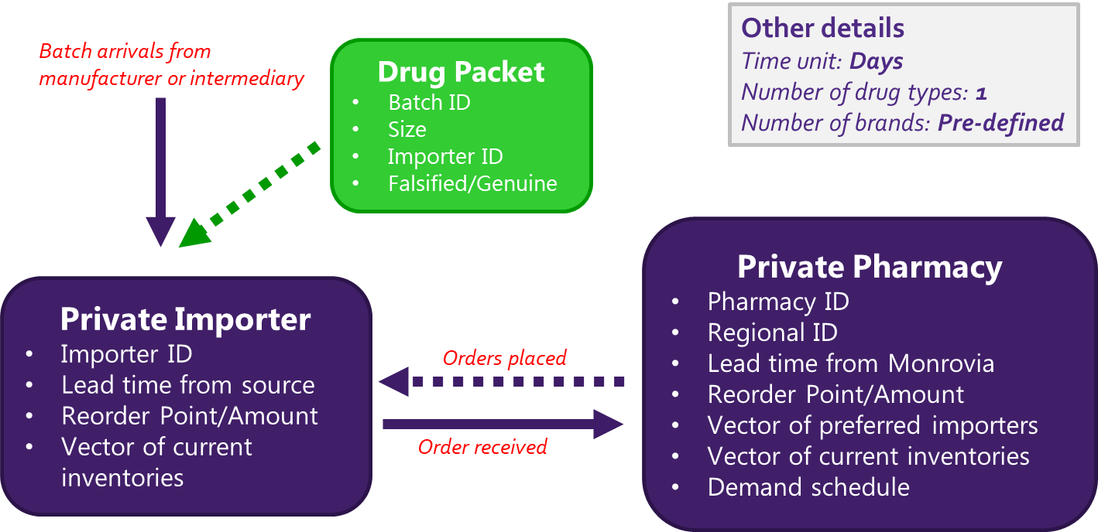

## Timeline at the pharmacy outlet (end node) level

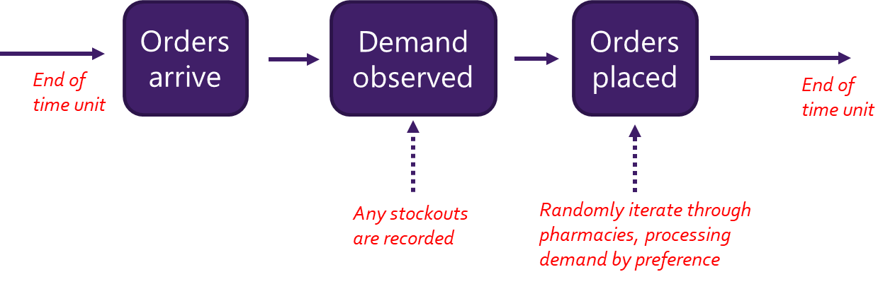

## Model Parameters

The following is a list of parameters that can be modified within the model:

* Reorder points/amount for different entities (i.e., internal policies)
* Lead times and global stockout rates (i.e. external factors)
* Underlying network structures
  + Number of importers that can be accessed by each outlet
  + Number of entities engaging with the falsifier node
  + Overall size/complexity
* Trigger sensitivities for entities opting to source from the falsifier node
* Testing policies and budgets

# Liberian Base Model

We make some assumptions in generating the Liberian base model, which acts as our best estimate of the scale and flow of Liberia’s private pharmaceutical supply chain for its 15 counties. These various assumptions may be adjusted for different configurations and scenarios:

* **1 falsifier node; 1 global manufacturer/supplier**: These are the two source nodes for all drug packet objects. Intermediate nodes (importers) may source from either node, while end nodes (pharmaceutical outlets) source either from intermediate nodes or the falsifier node.
* **10 importers**: During the September 2019 visit, it was established that there are roughly 10 major private importers of pharmaceuticals in Liberia that would provide the large majority of drugs for the private supply chain (especially antibiotics). This value could be adjusted for different pharmaceutical classes (doxycycline, ampicillin, etc.).
* **106 end nodes**: Currently we are only sure that there are 10 registered pharmacies in Bong County. Using population estimates, we extrapolate this knowledge to other counties, presuming that a similar pharmacy-per-capita ratio exists, which brings us to 106 total pharmacies in Liberia.
  + Ideally, we will have the exact number of registered outlets at some point.
* **Average demand per region**: The 2018 WHO Report on Surveillance of Antibiotic Consumption shows each of the surveilled African nations (4 total, excluding Liberia) consuming around 5 daily dosage XXx per 1000 inhabitants of beta-lactam antibacterials/penicillins. Amoxicillin falls under this umbrella and constitutes the most commonly consumed antibiotic in Liberia (amoxicillin signifies about 25% of this category in Burundi). Without differentiating, and assuming that we’re looking at all beta-lactam antibiotics in our simulation, we use an assumption of 5 days per treatment/blister pack to approximate a 1 blister pack/1000 inhabitants per day in Liberia.
  + These approximations can be greatly improved upon receiving importer information with respect to specific drugs, like amoxicillin, doxycycline, etc.
* **Average demand per pharmacy**: Once the demand per region is established, we can use the estimated pharmacy numbers to establish how much average demand should be experienced by each pharmacy. We assume pharmacies in a particular region see the same average demand.
* **Demand variability**: Using a target coefficient of variation of 0.5 and an assumed uniform distribution (lacking any other information on typical demands - Poisson would be just as reasonable, too), we can backwards solve the necessary upper/lower bounds on the uniform distribution to garner this desired CoV.
* **Lead time from Monrovia per region**: These values are best guesses from personal knowledge of round trips to and from each county of Liberia to the capital, Monrovia.
* **Inventory policies**: For the base model end nodes we set the reorder point equal to a 90% service rate and the reorder level equal to 15 days of mean demand. For intermediate nodes we use a 90% service rate relative to first-preference customers, and 60 days of mean demand.

# Building this model elsewhere

[hold]

# Moving Forward

The project will progress under the following steps:

1. Identify some base models and look at different output patterns
   1. What do different configurations look like with respect to the data we would observe?
   2. What is the effect of LT shocks? (Like when the southeastern region gets cut off from Monrovia)
2. *[To be discussed]*
3. …

# To-Do’s

*A list of items to complete:*

1. Put a smaller falsifier “order” amount in the “root” section of the ‘MakeOrder’ method
   * Should be triggered by the ‘current supplier’ node having the ‘FALSIFIER’ label
   * Potentially triggered by the current number of days stocked out, as well
   * Order amount is r/2
   * Record the number of triggers activated per entity
2. Generate ability to run batch files that vary different parameters
3. Put the “batch consumption rate” statistics in the simulation output
4. Streamline testing/sampling process into its own module
5. Implement "sandy" checks to ensure things are running smoothly without errors, outliers, etc.
6. Generate a “scratch folder”
7. Put the warm-up logic into its own module
8. Put the printed output logic into a module
9. Create output reader module for output dictionaries
10. Develop a procedure for what would be needed to build a simulation model in a much larger country like Nigeria
11. Put together a description of how the simulation model works
12. ~~Add sensitivity/specificity to testing results~~
13. ~~Add warm-up period~~
14. ~~Have multiple (100?) long warm-up periods that we sample from for each replication (as opposed to generating warm-up periods each time)~~
15. ~~Run multiple replications as opposed to long-run simulations~~